**Abstract**

Virtual Reality technologies are becoming really popular nowadays. Most people today have an easy to access to use such technologies, by assuming that now Google Cardboard technology can be accessed by only using smartphone. There are also devices that are built specifically to deliver a realistic virtual reality experience like Oculus Rift, and HTC Vive. Those two devices are now available on market and people can easily buy the device as it is made available for mass use. There is also a device named CAVE. This device needs a special room in order for it to operate. But the advantage is that this device can be used for many people in one session compared to Rift and Vive. On those available devices, one general question always emerges in people’s mind, which device that delivers the best realistic virtual reality experience. This research aims to answer this general question. By comparing and evaluating the test results of Oculus Rift, Google Cardboard, and CAVE, this question can be answered. In order to evaluate the realism that each device provides, a sample case is chosen. The case is walking activity. This case is chosen because walking is a daily ordinary activity that most people do and people will surely understand what kind of acceleration and realistic value an application must have. By this reason, an evaluation result can be obtained objectively and the comparison result will be clear enough to be determined.

1. **Introduction**
   1. **Background**

Virtual reality technology is improving and growing at a quick pace. This means that the needs of user to be integrated to the application using the virtual reality device is getting higher. The most common device used for VR is Google Cardboard. It’s because Google Cardboard only uses smartphone, which is owned by almost all people and the setup is not really complicated. But because it uses smartphone, the performance is always an issue for it to operate. There is another device called Oculus Rift. This device costs more than Google Cardboard and it can only be used to particularly display the image rendered only by PC, not even a notebook. But the advantage of using Oculus is that because this device is specialized in delivering the virtual reality environment, it focuses on enhancing the reality and runs smoothly as long as the PC meets the device requirement. By this fact, a research in finding which device has the best realistic experience is needed.

In this opportunity, a walking case is chosen as this case is the most common and basic case to be evaluated. Besides for evaluation purpose, this choice is also intended to integrate user’s daily routines and activities into the virtual reality so that the virtual reality application will be much more realistic and interactive.

* 1. **Objective**

1. Integrate user’s daily walking activity to the application using inertial sensor;
2. Evaluate which virtual reality device has the best realistic experience;
3. Evaluate which scene provides the most realistic experience.

1. **Design**

**2.1. System Component**

3 devices and 3 scenes will be used to compare which has the best realism. For Oculus Rift system, the components that will be used are as follow:

* PC is used to render the image;
* Oculus Rift, connected to PC, is used to detect the rotation, and to display the image;
* Smartphone is used to detect user’s movement using accelerometer, to calculate the cosine value, and to send the calculated cosine value to the PC via Access Point;
* Access Point is used to send data of the calculated cosine value from the smartphone to the PC.

The followings are the components that are used in Google Cardboard system:

* Display smartphone (Sony Xperia Z3 Compact) is used to render, to detect the rotation, and to display the image;
* Google Cardboard is used to place the first smartphone so that it can display the virtual reality image to the user;
* Motion detector smartphone (Samsung S4 Zoom) is used to detect user’s movement using accelerometer, to calculate the cosine value, and to send the calculated cosine value to the first smartphone via Access Point;
* Access Point is used to send data of the calculated cosine value from the first smartphone to the second smartphone.

While for the CAVE system, it is composed by the following components:

* PC is used to render the image;
* Projectors are used to display the image;
* Polhelmus G4 Rotation Sensor, connected to the PC, is used to detect the rotation. This sensor senses the rotation using electromagnetic wave. Basically it consists of one hub in which the rotation sensor is attached, one electromagnetic box to catch the sensor position and rotation (in this case the sensor’s position is not used), and one USB dongle connected to the PC to receive the data from the hub;
* Smartphone is used to detect user’s movement using accelerometer, to calculate the cosine value, and to send the calculated cosine value to the PC via Access Point;
* Access Point is used to send data of the calculated cosine value from the smartphone to the PC.

**2.2. System Configuration**

**2.2.1. Oculus Rift**

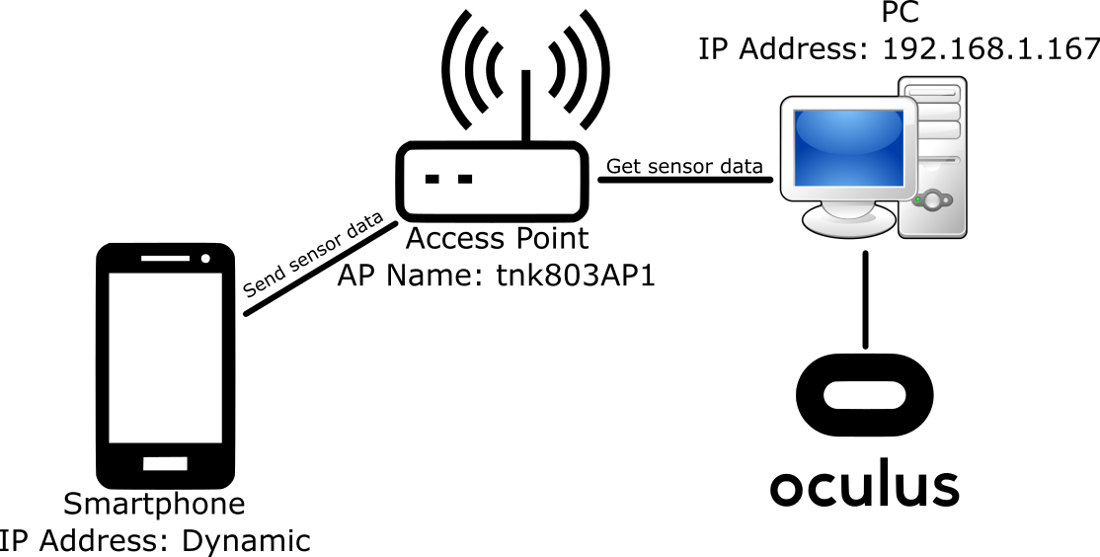

Figure 1. VR System Configuration by Oculus Rift

**2.2.2. Cardboard**

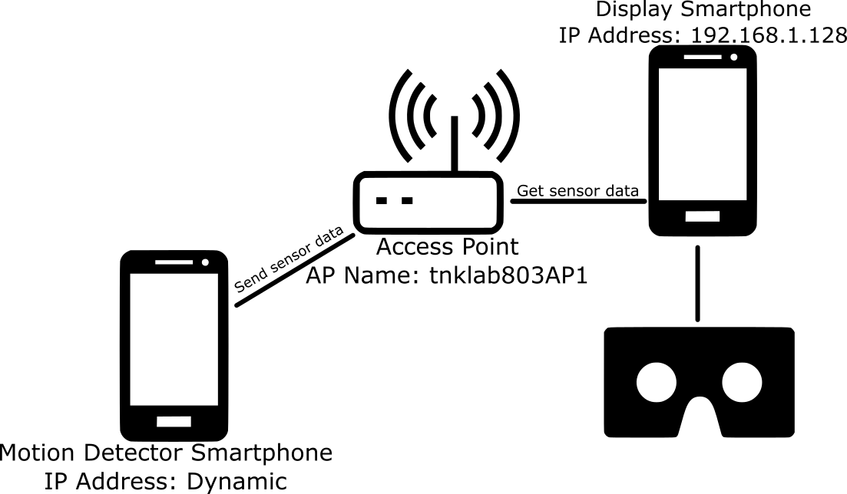

Figure 2. VR System Configuration by Google Cardboard

In order to send data between smartphone, the display smartphone is configured in order to have the static IP. After the static IP is defined, the smartphone that detects the motion can send the data to the provided IP address. Firstly, the motion detector smartphone’s accelerometer senses the user movement. After that it calculates the cosine value based on the obtained data from the accelerometer. After the calculation of the cosine value is done, the data is sent to the display smartphone.

**2.2.3. CAVE**

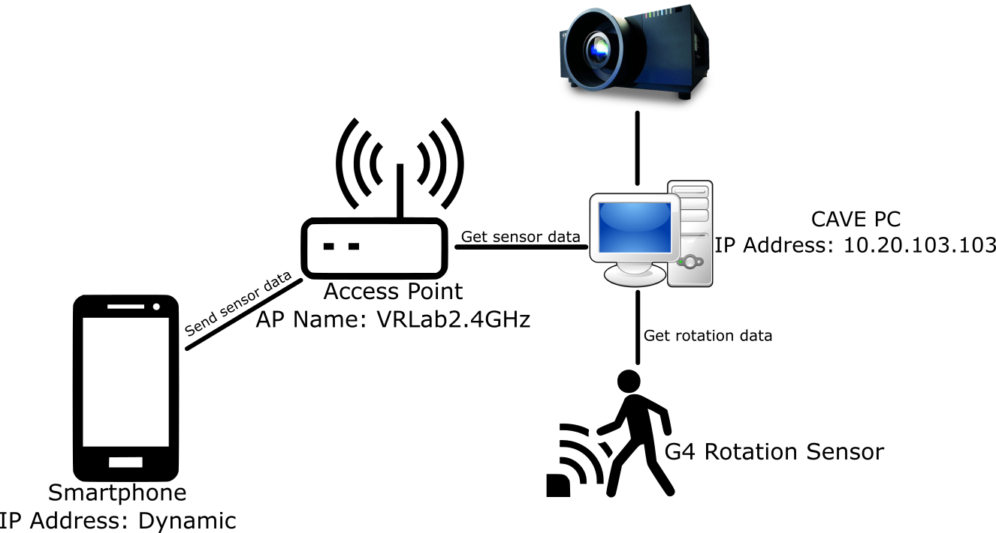

Figure 3. VR System Configuration by CAVE System

This CAVE system uses 1 high performance PC. The high performance PC is used to display 8 projectors that are connected directly to the 4 graphical processing units of the PC. Each graphical processing unit is responsible for 2 projectors. The view sides that are shown in Kanagawa Institute of Technology’s CAVE system are front, right, left, and bottom. Each view side has 2 projectors responsible for displaying the view side, one projector is for the right eye, and another one is for the left eye. The sensor data obtained from smartphone to detect the motion is sent via Access Point. The CAVE PC, high performance PC, will get the data sent from Access Point and increase the speed in application to change the scenery. G4 Rotation Sensor is connected directly to the PC and it will read the user’s rotation and change the direction of the walking.

**2.3. Scenes Photos**

The followings are series of photos of the scenes for each device:

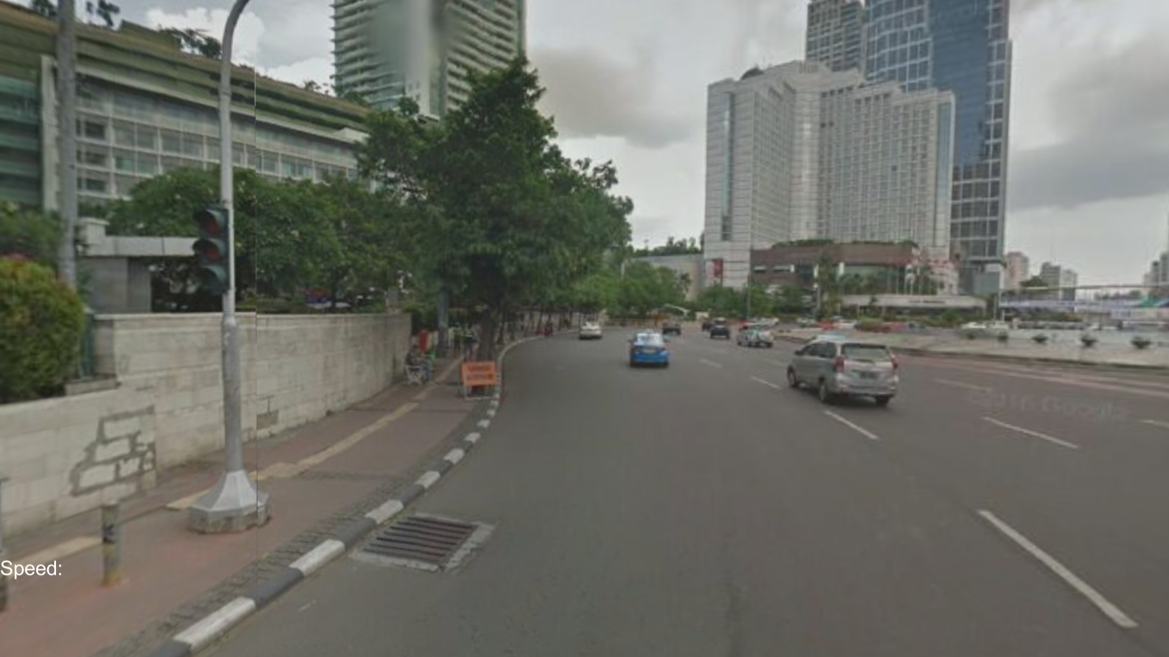

Figure 4. Google StreetView Scene

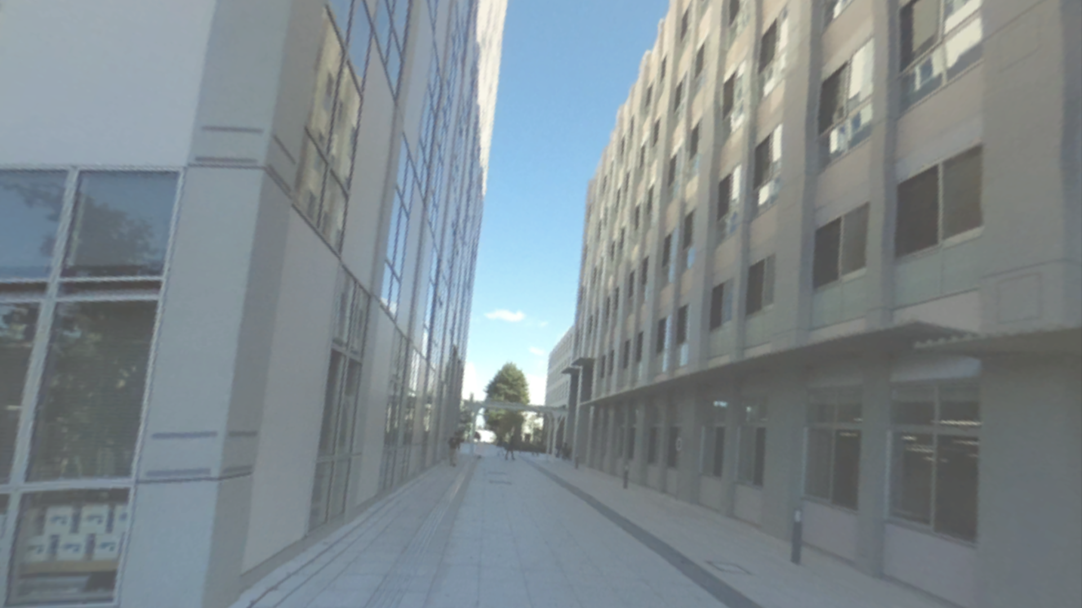

Figure 5. 360-Degree Camera Scene

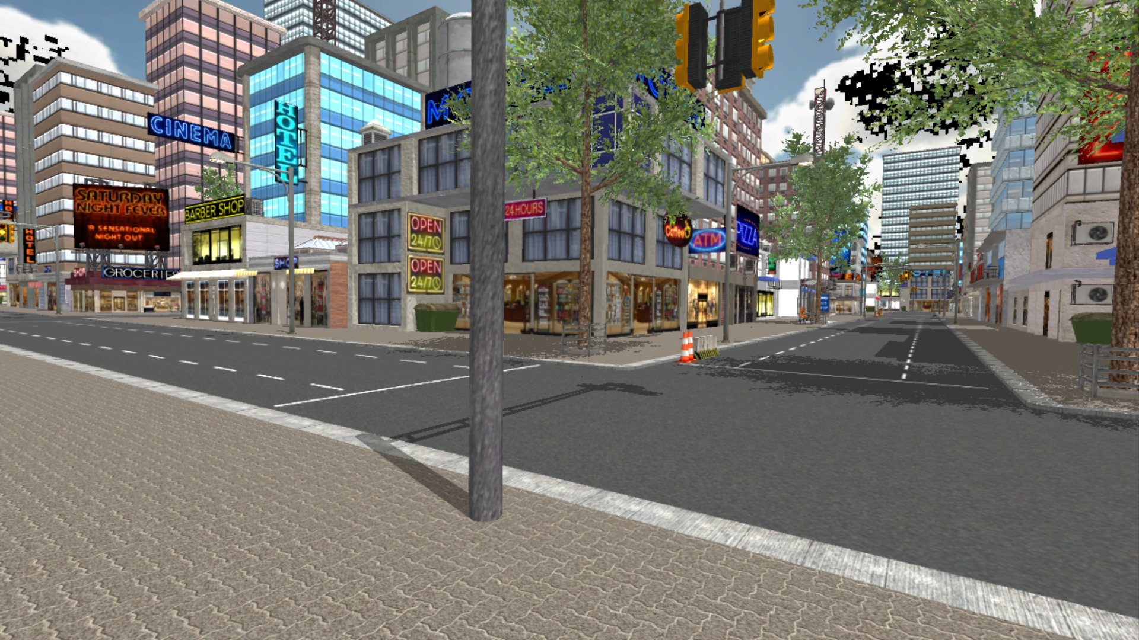

Figure 6. 3D Animation Scene

1. **Function Assignment**

**3.1. Rift**

PC (Processing Unit)

Phone (Motion Detector)

Send

(via LAN)

Detect movement using Accelerometer

Rotates Camera Around

Adds speed for the user to move in application if cosine exceeds threshold

Calculate

Cosine of X, Y, Z from Accelerometer

Send

(via Connected USB Cable)

Render Image

Rift (Display)

Detect Head Rotation

Display Calculated Image from PC

Figure 7. Oculus Rift Function Assignment

**3.2. Cardboard**

Detect Head Rotation and Rotates Camera Around

Display Calculated Image

Calculate

Send

(via LAN)

Adds speed for the user to move in application if cosine exceeds threshold

Display Phone (Processing Unit and Display)

Phone (Motion Detector)

Detect movement using Accelerometer

Cosine of X, Y, Z from Accelerometer

Figure 8. Google Cardboard Function Assignment

**3.3. CAVE**

Phone (Motion Detector)

Detect movement using Accelerometer

Cosine of X, Y, Z from Accelerometer

Calculate

PC (Processing Unit)

Adds speed for the user to move in application if cosine exceeds threshold

Rotates Camera Around

Send

(via LAN)

Render Image

Send

(via USB)

Polhelmus G4 (Rotation Sensor)

Get rotation data

Display Calculated Image from PC

CAVE (Display)

Figure 9. CAVE Function Assignment

1. **Signal Processing**

**4.1. Threshold Method**

This method mainly calculates the speed based on the calculated threshold. Every time new user uses this system; it needs calibration in order to match the threshold with the user’s walking style. The calibration is done by asking user to do 4 actions, those are walking, walking quickly, running, and running quickly. After the calibration is finished, the 4 datasets containing the value of the accelerometer from the 4 actions will be obtained. Those data will be used by calculating the distance that the users travelled by using this equation:

$$d_{i}=\sqrt{x_{i}^{2}+y_{i}^{2}+z_{i}^{2}}-\sqrt{x_{i-1}^{2}+y_{i-1}^{2}+z_{i-1}^{2}}$$

The distance travelled is represented $d_{i}$, $x$ is the x value of the accelerometer, $y$ is the y value, and $z$ is the z value. After the 4 datasets, walking dataset, walking quickly dataset, running dataset, and running quickly dataset, of calculated distance have been obtained, next is to set the threshold. Firstly, the threshold value is set to 0. After that every data on each dataset will be compared to the threshold value and counted how many data exceeds the threshold value. Each of the dataset will have number of data that exceeds the threshold value. Now that each dataset has number of data that exceeds the threshold value, it is then checked, if the walking dataset has less number of data than the walking quickly dataset, then if the walking quickly dataset has less number of data than the running dataset, and so on until the order is like this:

Number of data that exceeds threshold value from the walking dataset < the walking quickly dataset < the running dataset < the running quickly dataset

The threshold value is chosen, but if the order is not like above condition, then the threshold value will be added by 0.025 repeatedly and then compare it again to all 4 datasets until the above condition is fulfilled. After the threshold value is chosen, the speed can now be added. The speed can be added by using this simple formula:

calculated Speed = calculated speed + 0.005 * threshold

The number of 0.005 is used in order to match the UnityTM measurement unit. The value is chosen based on experiment. This method is very complicated and takes inefficient computational cost. This method is also not accurate in detecting the speed, as it does not increase the speed based on detecting the user’s movement, but it’s based on how quick the device is shaken instead. Furthermore, every new user uses the application, it needs to be recalibrated again, which is not convenient at all.

* 1. **Step Detection Method**

Every time the algorithm detects the step, it will increase the speed. The more step detected, the much more the speed will increase. The algorithm works by calculating the change of cosine value of the x, y, and z accelerometer of the sensor. If the cosine value falls below the defined threshold value, it will increase the step. According to Tomlein et al. (2012) [1], the expression is given below:

$$d_{i}={(\cos{α})}_{i}={\frac{x_{i}x_{i-1}+y_{i}y_{i-1}+z_{i}z_{i-1}}{\sqrt{x_{i}^{2}+y_{i}^{2}+z_{i}^{2}}\sqrt{x_{i-1}^{2}+y_{i-1}^{2}+z_{i-1}^{2}}}}$$

The value of $x$ is the x axis in which the accelerometer move, $y$ is for the y axis, and $z$ is for the z axis, while $i$ is the number of the i-th time the expression is used. The device is put on the right pocket of user. While inactive (no movement), the value is close to 1. To increase the precision of the measurement and to filter out the noise, the weighted moving average is used by calculating the last 10 values of d as shown on the formula below:

$${WMA}_{10}({d)}_{i}={{WMA}_{10}(\cos{α})}_{i}={\frac{10d_{i}+9d_{i-1}+…+d_{i-9}}{55}}$$

Based on experience, the quicker the user moves, the more the cosine value exceeds certain threshold. Summarily, the quicker the user moves, the more the fluctuation of the value will be. Below graphs are the comparison between walking and running:

Time (in Frame)

Cosine Value

Figure 10. Walking Graph

Time (in Frame)

Cosine Value

Figure 11. Running Graph

As can be seen from those two graphs, when the user runs, the value will fluctuate quickly compared to walking. Those two simple tests are done by using Samsung S4 Zoom’s Inertial Sensor. If a threshold value is set, then it can detect how many steps the users have taken. This threshold value is determined by experiment only and each device may have a various threshold value. For Samsung S4 Zoom’s case, the threshold value that is used is 0.96. The more the value exceeds the threshold value, the more number of steps detected, the faster it moves.

In UnityTM after the cosine value falls below the threshold value, it will increase the speed thus the camera in-game will move as if the user is walking. If it is inactive, the camera movement will stop. An interval is used so that the walking motion will be felt continuous. A 0.2 second interval is used in this case. Using interval still holds an issue as when the user stops moving, there will be a 0.2 seconds interval in order for the camera to stop moving. But after testing, this delay can actually be ignored as it does not deprive the realistic experience.

Delay happens if the message receiver method is placed inside the Update function on UnityTM, because it will just receive the message as quick as the Update function is called. So FixedUpdate function is used instead to constantly call a function in defined interval.

This step detection method is definitely used in this research as it is more efficient and also more accurate in detecting the user movement. Usually in real life, the faster the user runs, the more step they will do. So that by detecting the number of steps, it can represent how fast the user moves.

How the system works can be described on the following flowchart:



Get Rotation Data from Each Device’s Rotation Sensor

Figure 12. System Flowchart

1. **Evaluation**

**5.1. Experiment Purpose**

The experiment in this research is the most crucial things as it represents the main purpose of this research. The purpose of the experiment mainly is to understand which device and scene that are the most realistic. After the data is obtained by giving the participants the questionnaire, the results from the questionnaire will be summarized and from that point each device and scene realism can be analyzed and concluded.

**5.2. Experiment Method**

Participants will be collected to try each device, Oculus Rift, Google Cardboard, and CAVE VR, and each scene for each device, Google StreetView, 360-degree camera, and 3D animation scene, in order to obtain the result of which is the most realistic device and scene. Participants will be instructed to do the following steps:

* A brief explanation will be given to the participants of how the system works to help the participants understand the experiment purpose;
* A questionnaire will be provided at first and the participants must read the questionnaire in order to understand what matters that will be evaluated on the experiment;
* Participants will be instructed to walk for 20 seconds and to walk for 20 seconds too for each scene and each device;
* After they have completed the instruction for all scenes of each device, they will be told to fill in the questionnaire. This step repeats for the other devices too;
* Finally, after they have tested all scenes and all devices, they will be instructed to fill in the opinion section.

The questionnaire contains following items:

**Question section:**

1. How much do you feel the immersion of the provided device?
2. Do you feel any dizziness or nausea using the provided device?
3. How do you feel the realism when the objects are passing by as you keep moving on?
4. Do you feel the difference when you walk and when you run on the application? Does it represent how fast you move?
5. Please rate between 1-5 on the following table based on how each device and scene provides the realistic experience to you.

**Opinion section:**

1. Please write the weaknesses of the three devices.
2. Please tell your idea in order to make the application more realistic.
   1. **Experiment Result**

The test that involves 11 participants has been commenced. The following are the results of the test.

* + 1. **Comparison by Devices (Oculus Rift, Google Cardboard, CAVE System)**

Rank

Number of People

Number of People

Rank

Number of People

Rank

Figure 13. Series of Graphs Showing 3 Devices Experiment Results

Using a simple average calculation, the results can be obtained as follow:

1. Oculus Rift
   1. Immersion’s average, 4.09
   2. Dizziness level average, 1.91
2. Google Cardboard
   1. Immersion’s average, 3.09
   2. Dizziness level average, 2.45
3. CAVE
   1. Immersion’s average, 4.09
   2. Dizziness level average, 1.72

Seeing from above result, Google Cardboard has the lowest immersion among the other devices and also the highest dizziness level. According to the questionnaire’s opinion section answers, the causes of the low immersion value are because the field of view is narrow, the performance issue as this device only renders fewer number of framerate per second compared to Oculus Rift, and the resolution is very low so that everything feels so small compared to Oculus Rift. After that regarding the highest dizziness level of this device, it is mainly due to the fact that almost all of the participants feel unnecessary vibration. One of the possible explanation for this problem is because the inertial sensor that is planted on the smartphone is not as accurate as the sensor in Oculus Rift.

The next device is the Oculus Rift. This device has the same immersion value as CAVE, but the dizziness level is a bit higher than the CAVE system. According to the answer in opinion section, this device has a high immersive experience. When the experiment was undergoing, some of the participants feel as if they are really in the virtual world, and this is a distinctive advantage of using Oculus Rift. But because this device is connected to the PC using cable, it limits the user’s movement, thus depriving the realistic value of this device. Some of the participants also crashed during the experiment due to the fact that this device is not equipped with additional component in order to raise the room awareness, for example detecting the obstacle in front of the user, or seeing the environment around the room, so that it will not crash the user when their head is fully covered with the device. The dizziness level in this device is mainly caused by the display that gets blurry at some point because of little slip of the head while wearing the device. Sometimes the user has to adjust the head repeatedly in order to make the display clear again. This is quite uncomfortable as the blurry display will make the user dizzy. The stereoscopic view also makes some of the users dizzy.

The last device is CAVE. It has the same immersion as the Oculus Rift and the lowest dizziness level. This device mainly uses optical illusion. In this CAVE system, each view side is displayed by 2 projectors. One for the right eye, and another one for the left eye. When a 3D glasses is used, those view side will be perceived as one picture and the user can feel as if the image is real. Furthermore, in agreement with the participants’ opinion, this device is easy to use. Just put the 3D glasses and it is ready to be used. Because this device does not isolate the virtual world and the real world completely, unlike the other two devices, it doesn’t encounter any virtual sickness problem. That is why it has the lowest dizziness level. The disadvantage of the used CAVE system in this research is that because the shape is like a cube, there are some corners on the system. Those corners deprive the realistic value of this system, but not by much.

* + 1. **Comparison by Scenes (Google StreetView, 360-degree Camera, 3D Animation Scene)**

These next series of graphs are the results of the three mentioned scenes:

Number of People

Number of People

Rank

Rank

Number of People

Rank

Number of People

Rank

Rank

Number of People

Number of People

Rank

Figure 14. Series of Graphs Showing 3 Scenes Experiment Results

Using simple average calculation method, the result of the scenes is as follow:

1. Google StreetView realism feeling
   1. Using Oculus Rift, 2.27
   2. Using Google Cardboard, 1.91
   3. Using CAVE, 2.1
2. 360-degree Camera realism feeling
   1. Using Oculus Rift, 2.91
   2. Using Google Cardboard, 2.36
   3. Using CAVE, 2.91
3. 3D Animation realism feeling
   1. Using Oculus Rift, 4.27
   2. Using Google Cardboard, 4.27
   3. Using CAVE, 4.54
4. Google StreetView acceleration feeling
   1. Using Oculus Rift, 2.63
   2. Using Google Cardboard, 2.45
   3. Using CAVE, 2.63
5. 360-degree Camera acceleration feeling
   1. Using Oculus Rift, 2.91
   2. Using Google Cardboard, 2.54
   3. Using CAVE, 3.63
6. 3D Animation acceleration feeling
   1. Using Oculus Rift, 4.36
   2. Using Google Cardboard, 4.1
   3. Using CAVE, 4.36

As can be seen above, from three scenes that are used to test the device, CAVE is the best among the other devices. This scenes test result confirms the previous device test results that CAVE has the best immersion. Also in this result, it can be seen that among the other 2 scenes, the 3D scene scores big numbers and leaves the other scenes far behind. This is due to the fact that in 3D animation scene, user can freely move inside the scene, compared to the other scenes that can only move forward. Because of Google Cardboard’s performance issue, the 3D scene that is used in this test is composed using low poly model. In accordance with the opinion of one participant that says if the 3D scene is composed using high definition model, it will improve the realism of the 3D scene drastically.

360-degree camera scores a bit better than Google StreetView. This is because the image that is captured using 360-degree camera can be adjusted and also has higher resolution than the Google StreetView. Another reason is in order to obtain one set of image from Google StreetView, 6 images for front, right, left, back, top, and bottom must be captured and attached to the cube-shaped object in the application, compared to 360-degree camera that captures only one image and then attached to the sphere-shaped object in the application. But the concept between Google StreetView and 360-degree camera is still similar, so that participants only feel a tiny difference when using those two scenes.

* + 1. **Overall Realism**

The next series of graphs below are the results of overall realism:

Rank

Number of People

Number of People

Rank

Number of People

Rank

Figure 15. Overall Realism of 3 Scenes and Devices

By calculating the average of the result, these are the following realism scores for each scene:

1. Google StreetView overall realism
   1. Oculus Rift, 2.64
   2. Google Cardboard, 2.1
   3. CAVE, 2.18
2. 360-degree Camera overall realism
   1. Oculus Rift, 3.27
   2. Google Cardboard, 2.54
   3. CAVE, 3.27
3. 3D Animation overall realism
   1. Oculus Rift, 4.27
   2. Google Cardboard, 3.91
   3. CAVE, 4.54
      1. **Experiment Photos**

The followings are the photos taken during the experiment:

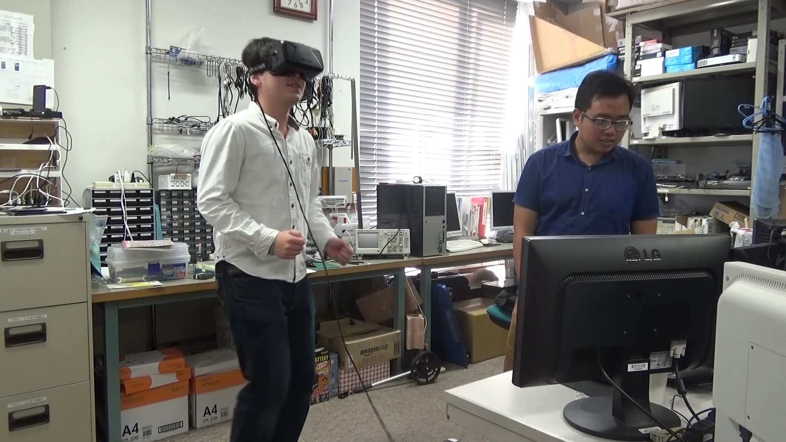

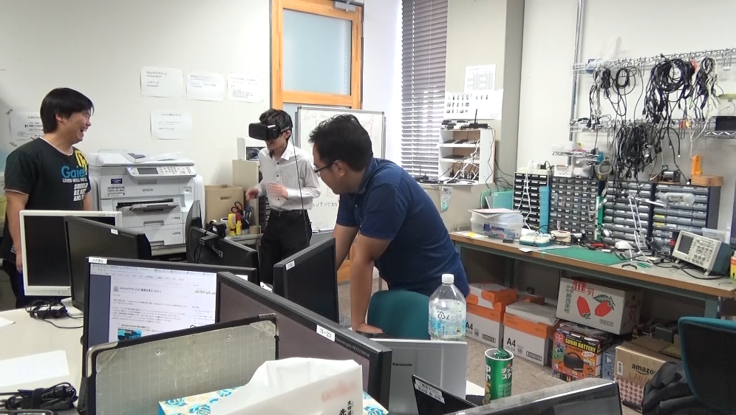

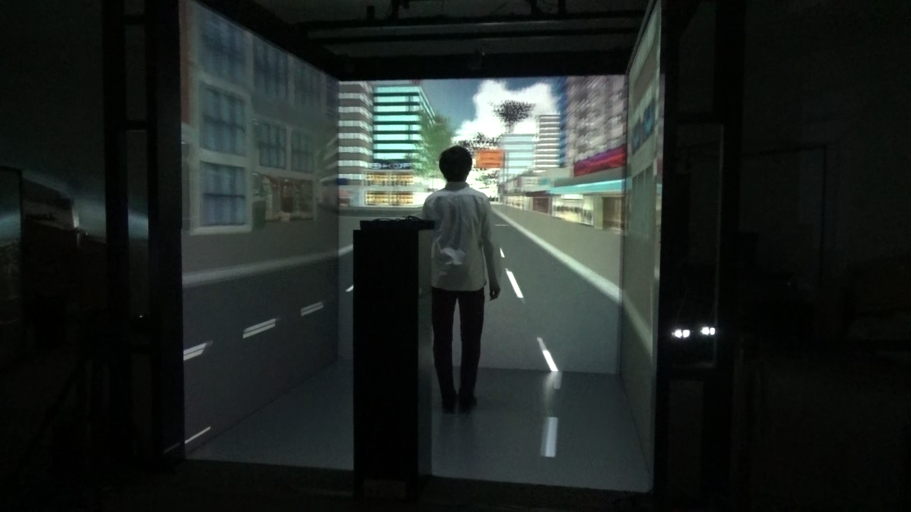

Figure 16. Series of Photos from Experiment

1. **Conclusion**

Integrating user’s walking motion using smartphone proved to be a success in this occasion. The test participants can feel the acceleration between walking and running. But it still needs refinement and improvement in the future. As for example, one of the participant noticed that because the phone is put on the right pocket when the left leg is lifted, it will not be detected as a step. Overall whenever user runs or walks, the acceleration can still be felt by the user.

From seeing the result, in this occasion CAVE has proved to be the best device for the virtual reality in terms of realism. At the device test result, it has the same immersion quality as the Oculus Rift, but after taking a look at the scene results it scores better than the Oculus Rift. The order of the most to the least realistic device is CAVE, Oculus Rift, and Google Cardboard. But if the price of each device is taken into consideration, CAVE is not affordable for everyone. Furthermore, it needs a special room in order to operate, and high quality components compared to the other devices that only need small room and are very portable. For market, it is best to choose Oculus Rift instead as this device is much cheaper than CAVE but still provides a nice realistic experience. Google Cardboard is the last choice for people that only want to experience virtual reality without considering the realistic value.

The 3 scenes experiment result shows that 3D animation scene is, without any further consideration, the most realistic scene among the other scenes. Compared to the other scenes, it scores a big number of realism. This is because in 3D animation scene, user can move his/her body freely around the scene. Also the 3D models, that are used to compose the scene, are made by considering the scale of the real building in order to provide the realistic experience so that the user feels as if he/she is inside that scene. By taking a look at the experiment result again, the order of the most to the least realistic scene is 3D animation scene, 360-degree camera, and Google StreetView. 360-degree camera and Google StreetView almost has the same test result, but 360-degree camera still more realistic than Google StreetView. Furthermore, using the 360-degree camera, the scene can still be improved so that user can freely move around the scene.

1. **Future Works**

There are actually some points where this research can further advance. By encountering new problems that come after implementing some of the concepts, below are the things in which this research can still advance:

* Step detection method can be refined to prevent cheating, since as for now when the device is shaken, it still assumes shaking motion as walking motion;
* The current application for showing the 360-degree camera scene still provides discrete picture. In the future, those discrete pictures may be replaced by video in order to feel continuous;
* Also there is a possibility for the user to move around in the 360-degree camera scene instead of only walking straight;
* The accuracy of rotation detection on CAVE system using G4 system is still terrible. The better method of detecting rotation may be considered in the future;
* In the future, some motions may also be added. For instance, jumping, cycling, and flying using inertial sensor;
* Some of the participants still feel virtual reality sickness. In this occasion, some of them had shown postural instability during the test. This sickness only happens to the device that fully covers the participants’ head, in this case Google Cardboard and Oculus Rift. The definite cause of this matter can be investigated in the future work;
* Because the smartphone for detecting the motion is put on the right pocket, every user moves his/her left leg, it is considered as idle. Further investigation is needed so that when the user moves the left leg, it can be considered as moving;
* The movement is still not that smooth. This fact may still need to be investigated in the future so that the smooth movement can be felt.

**References**

[1]Tomlein, Michal, et al. Advanced Pedometer for Smartphone-Based Activity Tracking. International Conference on Health Informatics, page 2, 2012.

**Acknowledgement**

In this great opportunity to research in one of the developed country, I would express my best gratitude towards Professor Hiroshi Tanaka from Kanagawa Institute of Technology for giving me an opportunity, guidance in this research with his advices, and a plethora of his supports to make this research successful. Without his guidance and his supports, I cannot do this research as well as without his supports. I would also like to thank very much to Mr. Ebihara for lending me a bit of his cooperation in my research, helping me speak with people in Japanese in order to commence the test, and also willingness to be asked whenever I need help. I will also give this gratitude to Tanaka Lab’s members for their willingness to help me as the participants of the experiment on this research, as the experiment plays a very huge role on this occasion, and some participants from the various lab besides Tanaka Lab that have been also involved in the experiment. I would also like to thank Professor Tetsuri as the manager of the CAVE room. Without his support, I cannot commence the test and evaluate this research using CAVE.

A very special thanks goes to my parents for letting me and guaranteeing me from the very beginning of this research program until the end of this program. Without their help, I cannot even depart from my home country to start this great opportunity that gives me a lot of benefits for now and the future. There are still a lot of people that have given their support to me in which I cannot really mention all of them, as it would go as an endless list of gratitude. But all in all, to everyone that has supported me, I could not say any better word than “thank you” to express my huge gratitude towards everyone.

**Appendix**

**Components Specification**

1. PC:
   1. Intel Core i7-6700 @ 3.40 GHz
   2. ZOTAC GeForce GTX 1070 GDDR5 8 GB
   3. DDR4 Memory 16 GB
2. Oculus Rift DK2:
   1. 960x1080 resolution per eye
   2. 75 Hz, 72 Hz, or 60 Hz refresh rate
   3. Gyroscope, Accelerometer, Magnetometer, Near Infrared, and CMOS sensors
3. Samsung S4 Zoom (Motion Detector):
   1. ARM Cortex-A9 Dual-core @ 1500 MHz
   2. 1.5 GB system memory
   3. Accelerometer, Gyroscope, and Compass sensors
4. CAVE High Performance PC:
   1. Intel Xeon CPU E5-2650 V2 @ 2.6 GHz
   2. DDR4 Memory 32 GB
   3. 4 x NVIDIA Quadro K5200 GDDR5 4GB
5. Polhelmus G4 Rotation and Position Sensor System
   1. A USB dongle connected to the PC to retrieve the sensor data
   2. A hub that uses Bluetooth or USB to send the data of the rotation sensor
   3. A sensor connected to the hub to detect the rotation
   4. A source box that emits electromagnetic wave which can detect the sensor’s position and orientation
6. Sony Xperia Z3 Compact (Display Smartphone):
   1. Qualcomm MSM8974PRO-AC @ 2.46 GHz
   2. Adreno 330 GPU Renderer @ 578 MHz
   3. 1.5 GB system memory
   4. Accelerometer, Gyroscope, and Compass sensors

**Program List**

Below are the programs for the Oculus Rift that are used in this research. All programs are made using Unity3D version 5. The programs for showing the scenes can be directly copied and ran on the PC:

* Rift3DScene (This is for showing the 3D animation scene)
* Rift360Cam (This is for showing the 360-degree camera scene)
* RiftStreetView (This is for showing the Google StreetView scene)
* RiftController.apk (This application is installed on the motion detector smartphone)

The followings are the programs for the Google Cardboard used in this research. All programs are made using Unity3D version 5. The programs for showing the scenes are installed on the display smartphone:

* Cardboard.apk (This is for showing the 3D animation scene)
* Cardboard360.apk (This is for showing the 360-degree camera scene)
* CardboardStreetView.apk (This is for showing the Google StreetView scene)
* CardboardController.apk (This application is installed on the motion detector smartphone)

The programs for the CAVE system used in this research can be seen below. All programs are made using Unity3D version 5. The programs for showing the scenes can be directly copied and ran on the CAVE system’s PC:

* CAVE3DScene (This is for showing the 3D animation scene)
* CAVE360Camera (This is for showing the 360-degree camera scene)
* CAVEStreetView (This is for showing the Google StreetView scene)
* CAVEController.apk (This application is installed on the motion detector smartphone. Note: Because CAVE PC’s IP Address is not static, connect the smartphone first to the access point mentioned on the system configuration section and then turn on the CAVE PC in order to be connected)
* PIStream (This program is used to run the G4 rotation sensor. The file named “UnityExport.exe” inside this folder must be run prior to running the scene program to detect the rotation)

**Manual**

Below are the steps that need to be done in order to run the application for Oculus Rift:

1. Connect the Oculus Rift to the PC;
2. Install the Oculus Rift Driver;
3. Install the apk file named RiftController.apk on the motion detector smartphone;
4. Connect the motion detector smartphone to the access point named tnk803AP1 or tnk803AP2-2.4;
5. If the installation is successful, the application named VRController will appear on the phone menu. Run the application and now the phone is ready to detect the motion;
6. There are 3 applications separated by the folders (in this case the folders’ names are “Rift360Cam”, “RiftStreetView”, “Rift3DScene”). Each application shows the 360-degree camera, Google StreetView, and 3D Animation scene. Choose one folder to open. Inside the folder there are 2 items, the assets folder and the executable file. Run the executable file and press play directly;
7. Put the motion detector smartphone on the right pocket;
8. Wear the Oculus Rift headset and start walking freely.

Below are the steps that need to be done in order to run the application for CAVE:

1. Install the apk file named CAVEController.apk on the motion detector smartphone;
2. Connect the motion detector smartphone to the access point named VRLab24GHz;
3. If the installation is successful, the application named VRControllerCAVE will appear on the phone menu. Run the application and now the phone is ready to detect the motion;
4. There are 3 applications separated by the folders (in this case the folders’ names are “CAVE360Cam”, “CAVEStreetView”, “CAVE3DScene”). Each application shows the 360-degree camera, Google StreetView, and 3D Animation scene. Choose one folder to open. Inside the folder there are 2 items, the assets folder and the executable file. Run the executable file and press play directly;
5. Put the motion detector smartphone on the right pocket;
6. There is a folder named PIStream on the deployed application folder. Open the folder and run the UnityExport.exe to get the rotation data from Polhelmus G4 Sensor;
7. Attach the G4 hub to the body and also attach the sensor, that is connected to the hub, to the glasses;
8. Go to the center of the CAVE system and start walking in place.

Below are the steps that need to be done in order to run the application for Google Cardboard:

1. There are 3 applications which names are “Cardboard.apk” for 3D animation scene, “Cardboard360.apk” for 360-degree camera, and “CardboardStreetView.apk” for Google StreetView. Pick any application to be installed on the display smartphone;
2. If the installation is successful, the application named VRProject3D for 3D animation scene, VRStreetView for Google StreetView, or VRProject360 for 360-degree camera will appear on the phone menu. Run the application and put the display smartphone on the cardboard;
3. Connect the display smartphone to the access point named tnk803API1 and set the IP to static with IP Address of 192.168.1.128
4. Install the apk file named CardboardController.apk on the motion detector smartphone;
5. Connect the motion detector smartphone to the access point named tnk803AP1 or tnk803AP2-2.4;
6. If the installation is successful, the application named VRControllerCardboard will appear on the phone menu. Run the application and now the phone is ready to detect the motion;
7. Put the motion detector smartphone on the right pocket;
8. Wear the cardboard and start walking freely.